EFolio for fit5032 week1

Zeyu Lin 34371400

Github Url: <https://github.com/Capet-Zeyu-Lin/fit5032-week1>

Screenshot1: app running

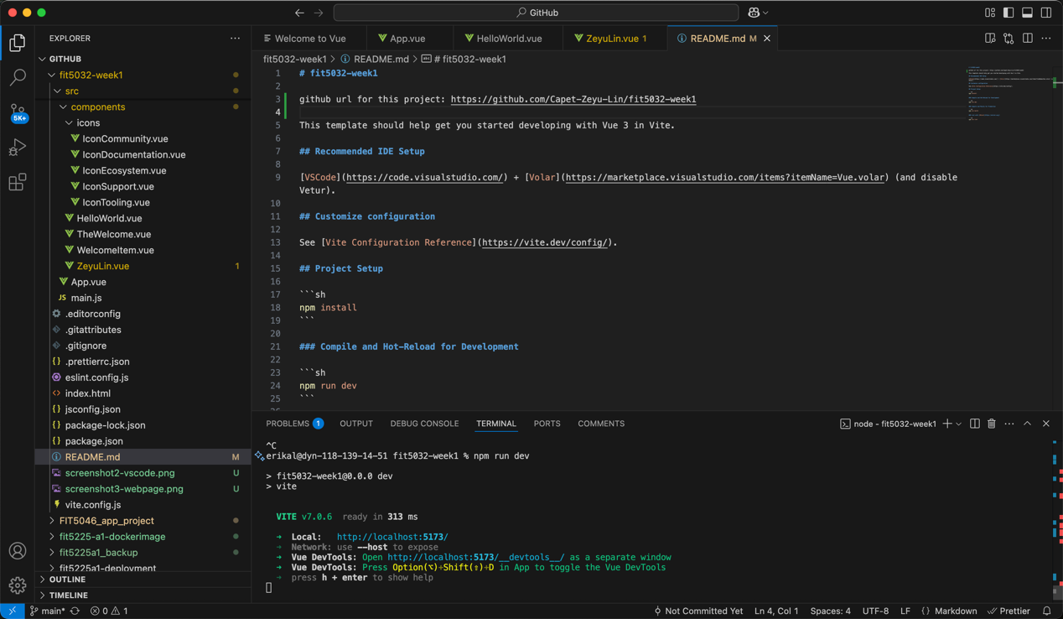

Screenshot2: the vue file

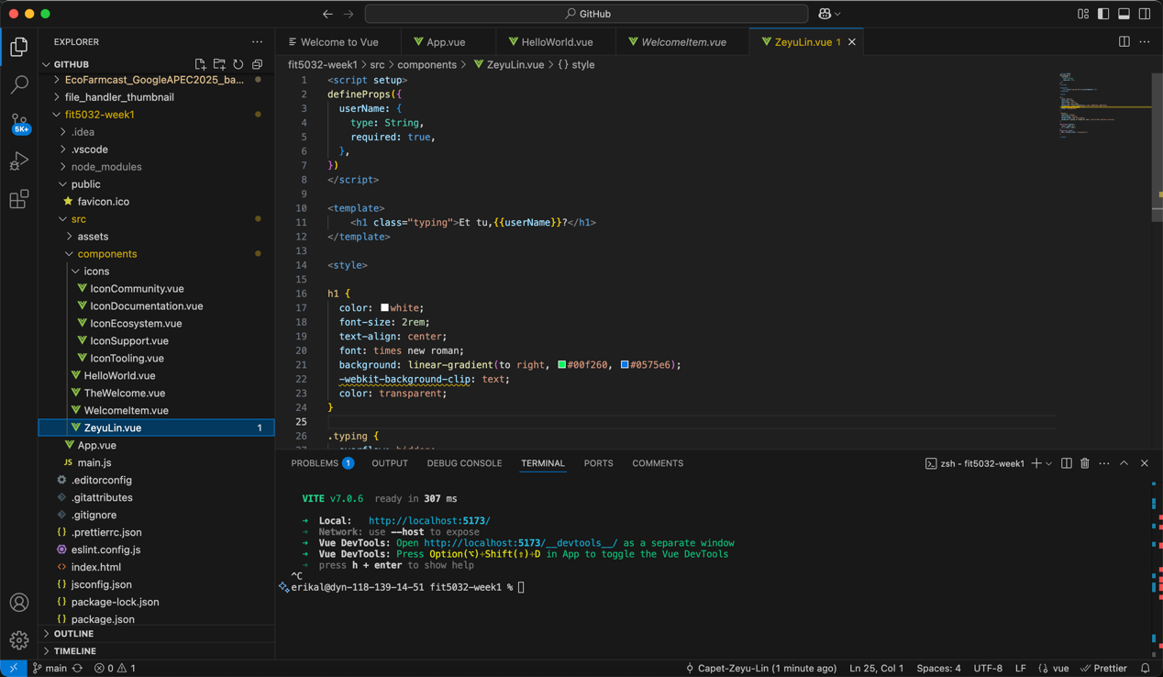

Screenshot3: the browser window.

